
Wildwood
Respect. Integrity. Creativity. Holism.

1190 Troy-Schenectady Road

Latham, New York 12110
P: (518) 640-3300
F: (518) 640-3401
wildwoodprograms.org

Individual’s Name:
Program Name:
Program Contact Name:
Phone Number:
Program Address:

Amount of Payment Received for Classes Below:
Day of the week | Date of attendance | Program Provider Initials | Note (if applicable)
Monday

Tuesday

Wednesday

Thursday

Friday

Saturday

Sunday

Enter the date(s) the individual attended the program and initial for each date specified.

- By signing this document I attest the information provided is accurate and true, and any willful misrepresentation will result in refunding of the reimbursement by the individual seeking reimbursement. Any willful misrepresentation and misuse of Medicaid funds will be reported to the appropriate officials for prosecution of Medicaid Fraud.

____________________________________ ___________ ______________
Program Representative Signature Initials Date

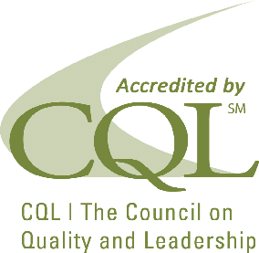
Strengthening the well-being of people with disabilities and their families through innovative supports.

